Chapter 16 Collections, Maps and Iterators

- Java Collection
  - any class that holds objects and implements the Collection interface
  - ArrayList<T> implements all the methods in the Collection interface
  - Collection is the highest level of Java’s framework for collection classes
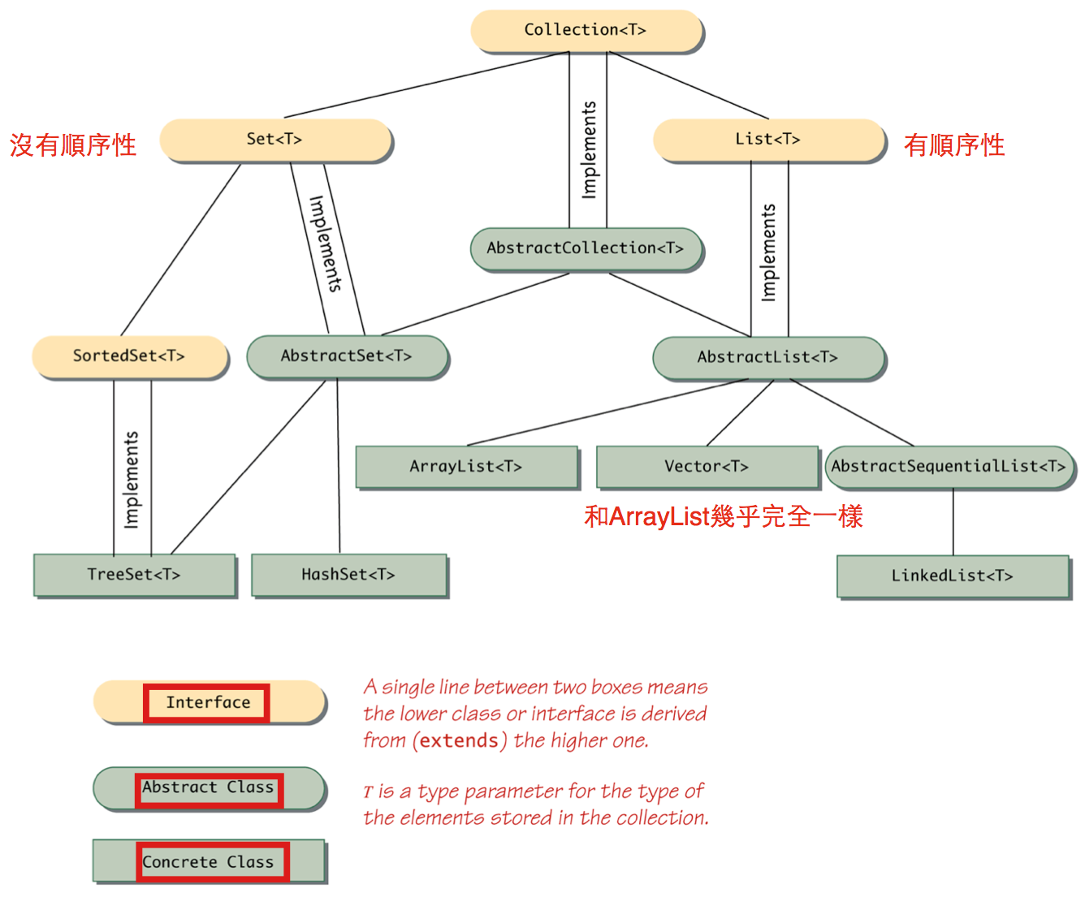

- Wildcards (【電腦】萬用字元，通配符)
  - no specified type parameter, use “?” to be a wide range of argument types
  - syntax:
public void method(String arg1, ArrayList<?> arg2)
  - bounded wildcards: specifying the type to be an ancestor type or descendent type of some class or interface
<? extends String> //descendent class of String
<? super String> //ancestor class of String
  - <個人補充>wildcards vs type parameter
<N extends Number> Collection<N> getThatCollection(Class<N> type)
Collection<? extends Number> getThatCollection(Class<? extends Number>)
    - first declaration: passed argument and return type are the same type
    - second declaration: passed argument and return type doesn’t have to be the same type
- Collection Framework
  - Collection<T> interface describes the basic operations that all collection classes should implement
  - method headings example
    - boolean isEmpty()
    - public boolean contains(Object target)
    - public boolean containsAll(Collection<?> collectionOfTargets)
    - public boolean equals(Object other)
    - public int size()
    - Iterator<T> iterator()
    - public Object[] toArray()
    - public <E> E[] toArray(E[] a)
    - public int hashCode()
    - public boolean add(T element) (Optional)
    - public boolean addAll(Collection<? extends T> collectionToAdd()) (Optional)
    - public boolean remove(Object element) (Optional)
    - public void clear() (Optional)
    - public boolean retainAll(Collection<?> saveElements) (Optional)
  - “Optional” operation means the method does not completely implement its intended semantics and still has to be implemented!!
  - If a trivial implementation is given, the method body should throw an UnsupportedOperationException
- Concrete Collections Classes
  - Set<T> interface has concrete classes such as…
    - HashSet<T>
    - TreeSet<T>
  - List<T> interface has concrete classes such as…
    - ArrayList<T>
    - Vector<T>
    - LinkedList<T>
- Map Framework
  - deals with collections of ordered pairs(key and associated value)
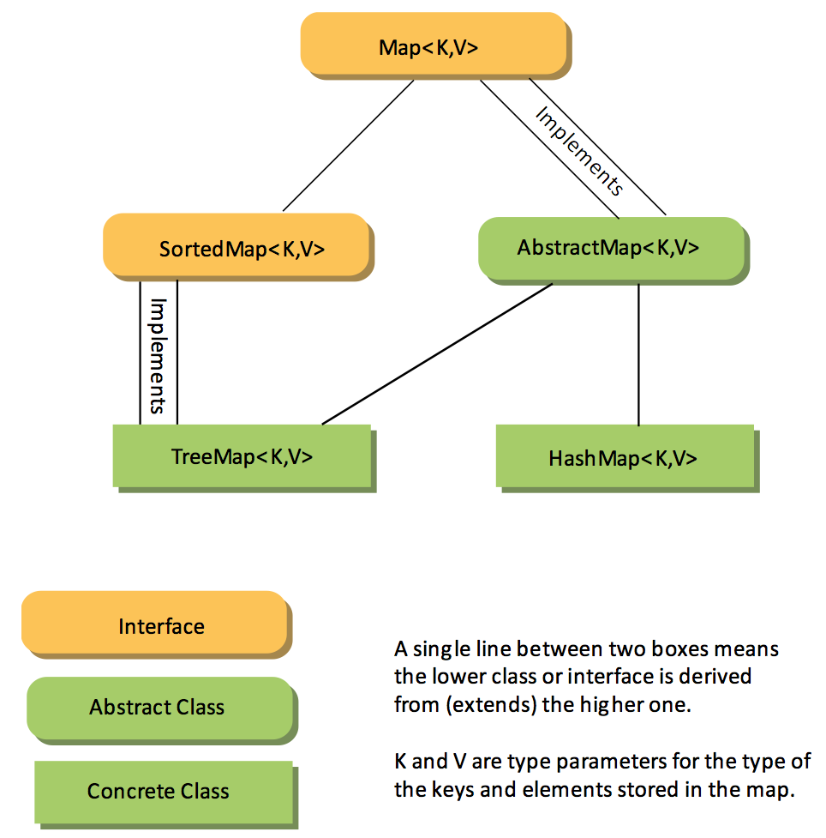
  - method headings
    - boolean isEmpty()
    - public boolean containsValue(Object value)
    - public boolean containsKey(Object key)
    - public boolean equals(Object other)
    - public int size()
    - public int hashCode()
    - public Set<Map.Entry<K,V>> entrySet()
    - public Collection<V> values()
    - public V get(Object key)
    - public V put(K key, V value) (Optional)
    - public void putAll(Map<? extends K, ? extends V> mapToAdd) (Optional)
    - public V remove(Object key) (Optional)
  - unordered map
    - HashMap<K,V>
      - load factor(between 0 and 1): If number of elements in hash table exceeds the load factor, then the capacity of the hash table is automatically increased (default is 0.75)
      - initial capacity is 16
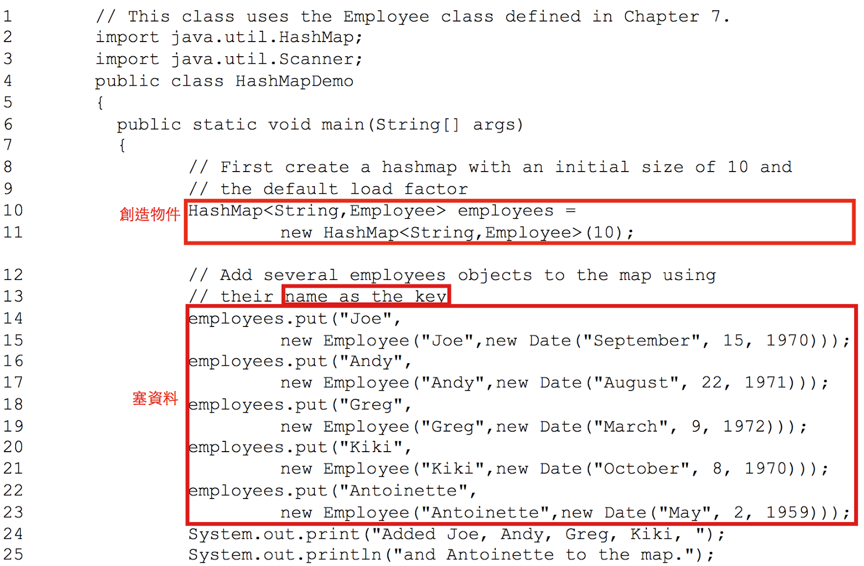
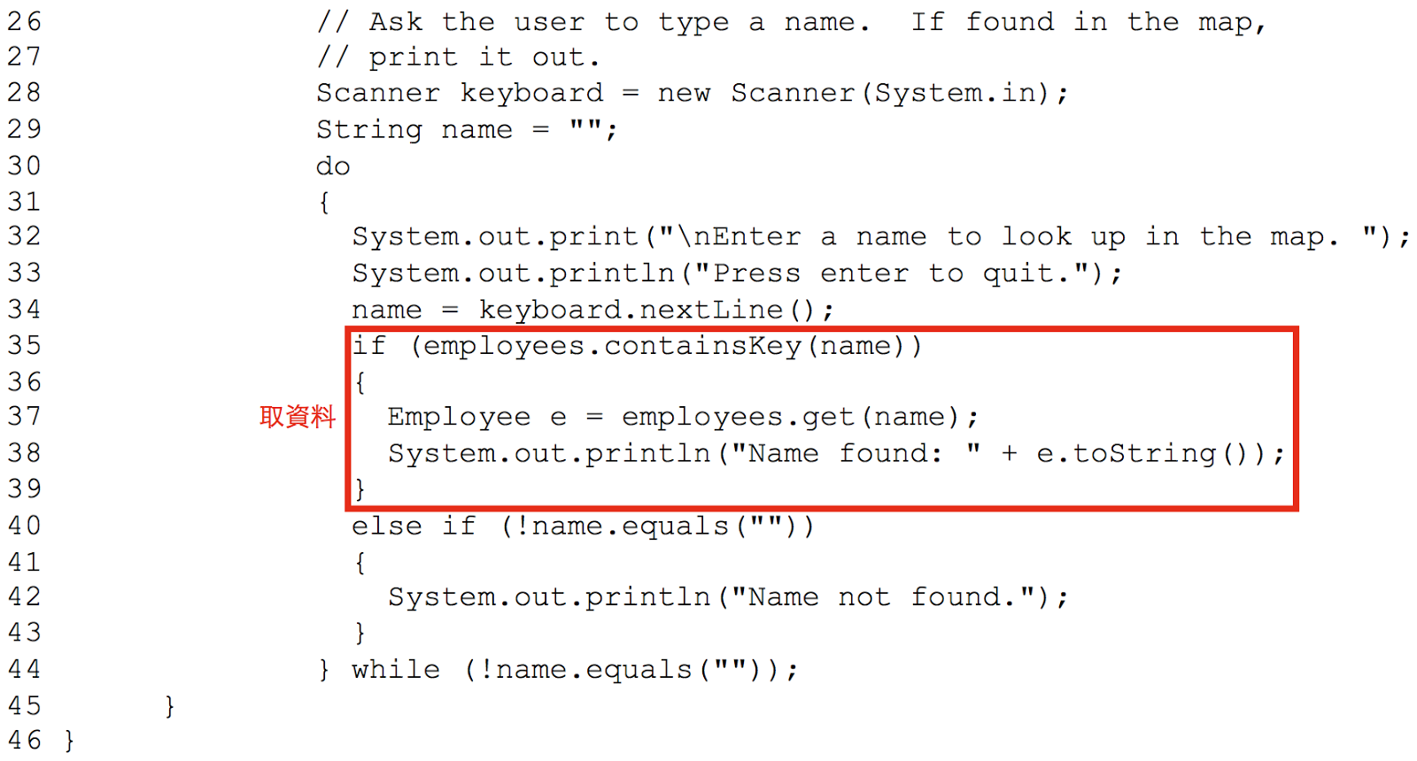
      - if want to use custom class as parameterized type K, then custom class need to override…
public int hashCode();
public boolean equals(Object obj);
  - ordered map
    - TreeMap<K, V>
    - LinkedHashMap<K, V>
- Iterators Interface
  - object that provide sequential access to the collection elements
  - method headings:
    - public T next()
    - public boolean hasNext()
    - public void remove() (Optional)
  - HashSet<T> object imposes no order on the elements it contains, but iterator will impose an order on the elements in the hash set
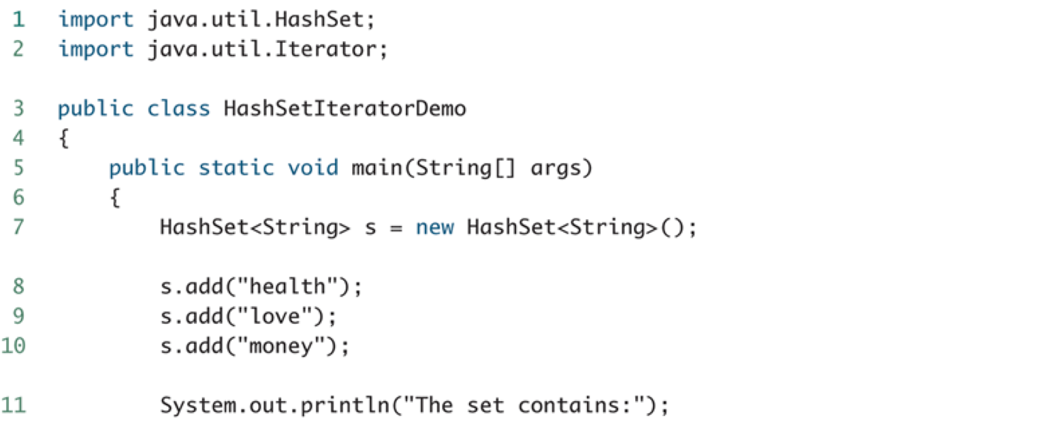
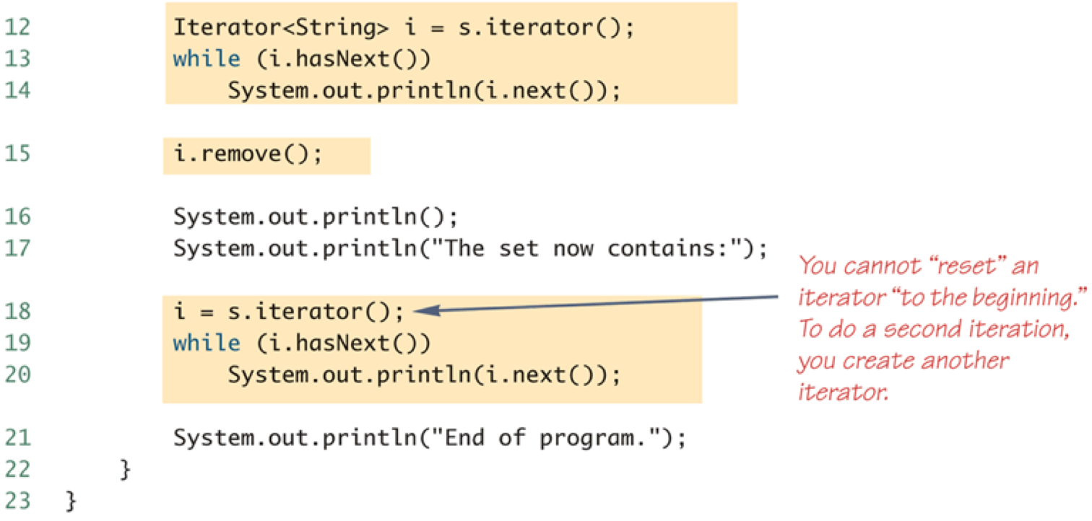
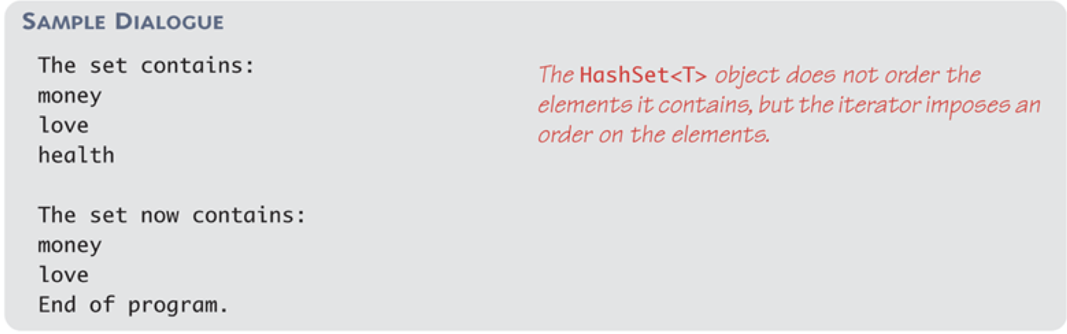
  - For-Each Loops can serve the same purpose as an iterator, same results as above
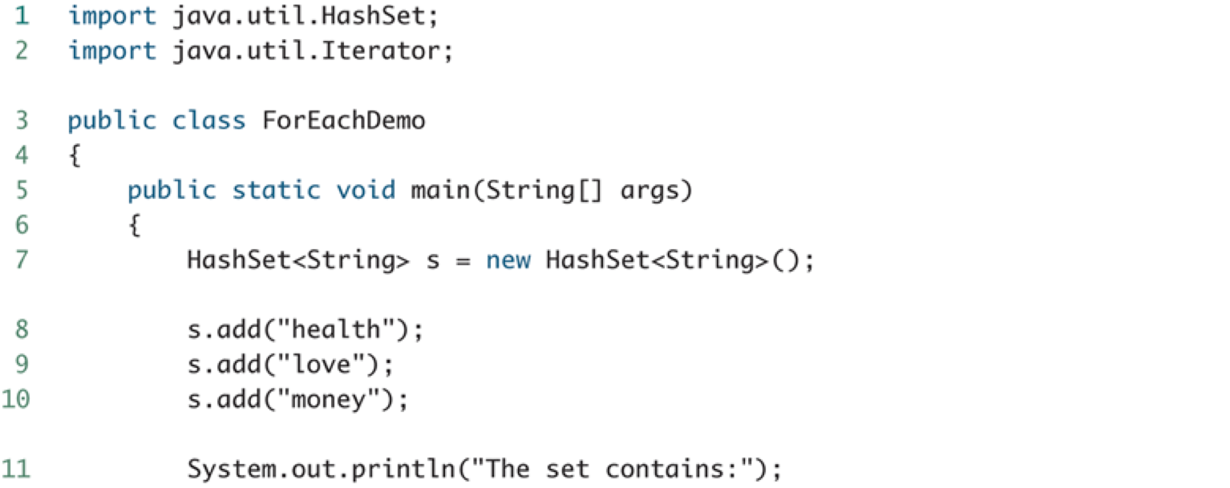
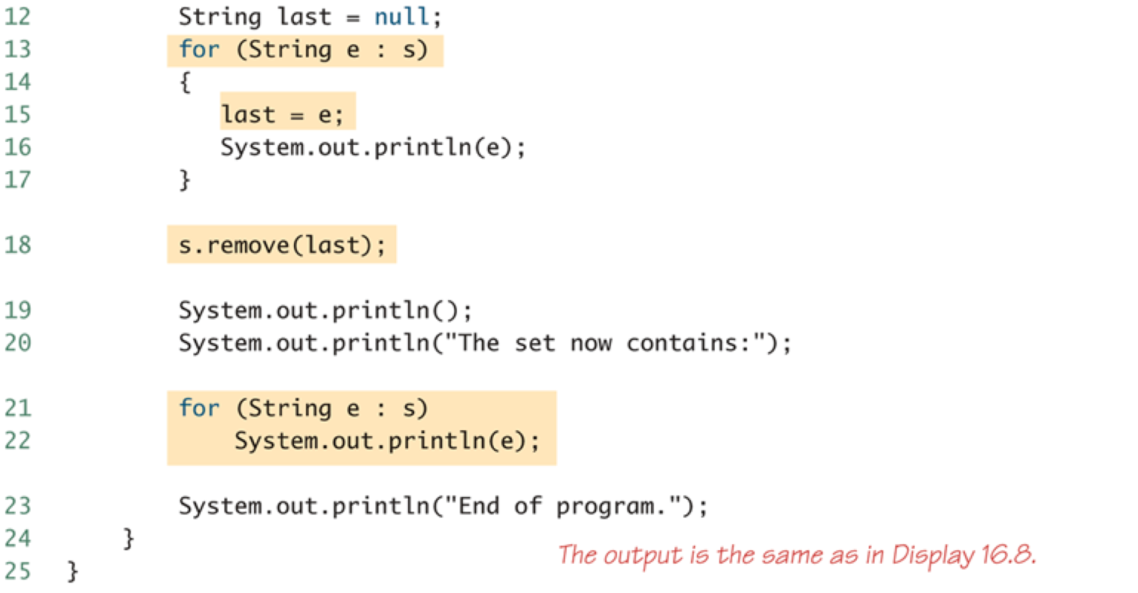

- ListIterator<T> interface
  - extends Iterator<T> interface
  - designed to work with collections that satify the List<T> interface
  - can move in either direction
  - method headings
    - public T next()
    - public T previous()
    - public boolean hasNext()
    - public int nextIndex()
    - public int previoudIndex()
    - public void add(T newElement) (Optional)
    - public void remove() (Optional)
    - public void set(T newElement) (Optional)
  - for example:

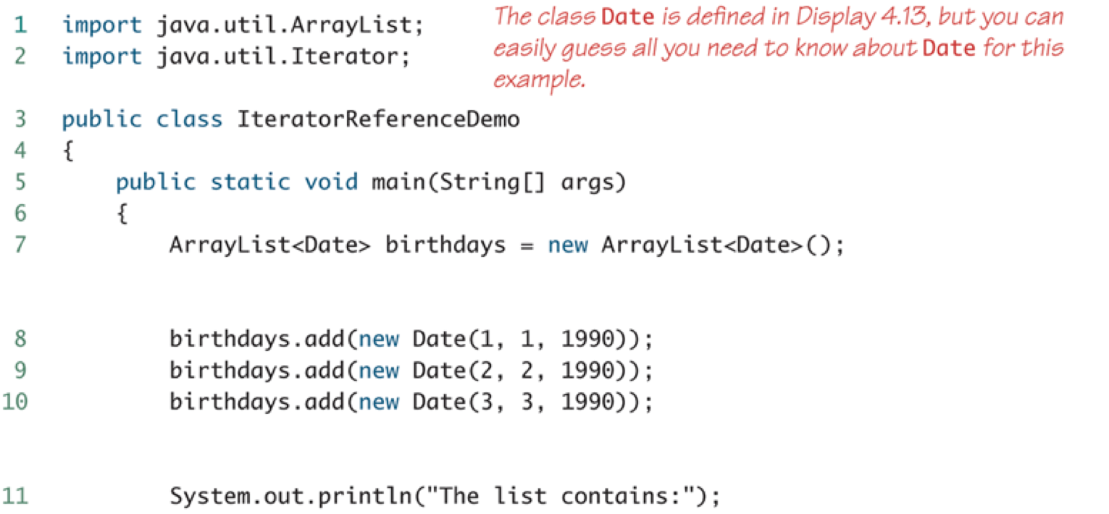
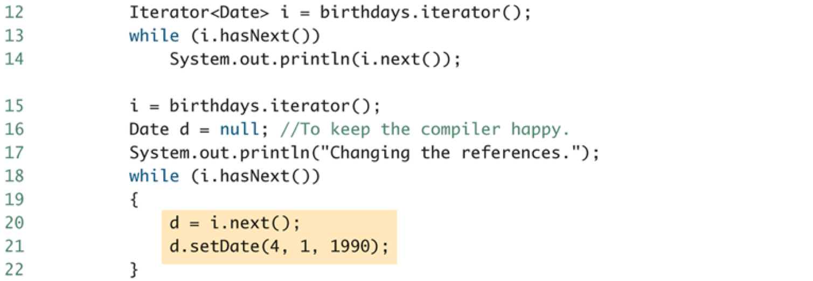
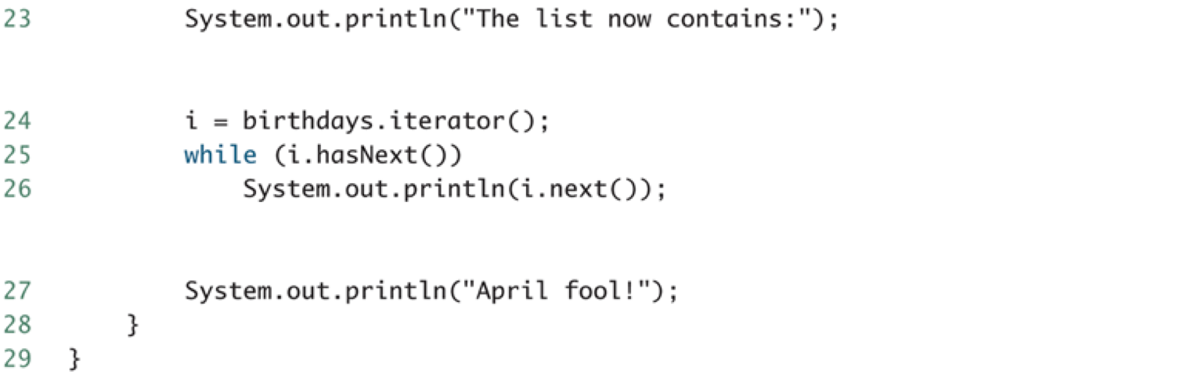
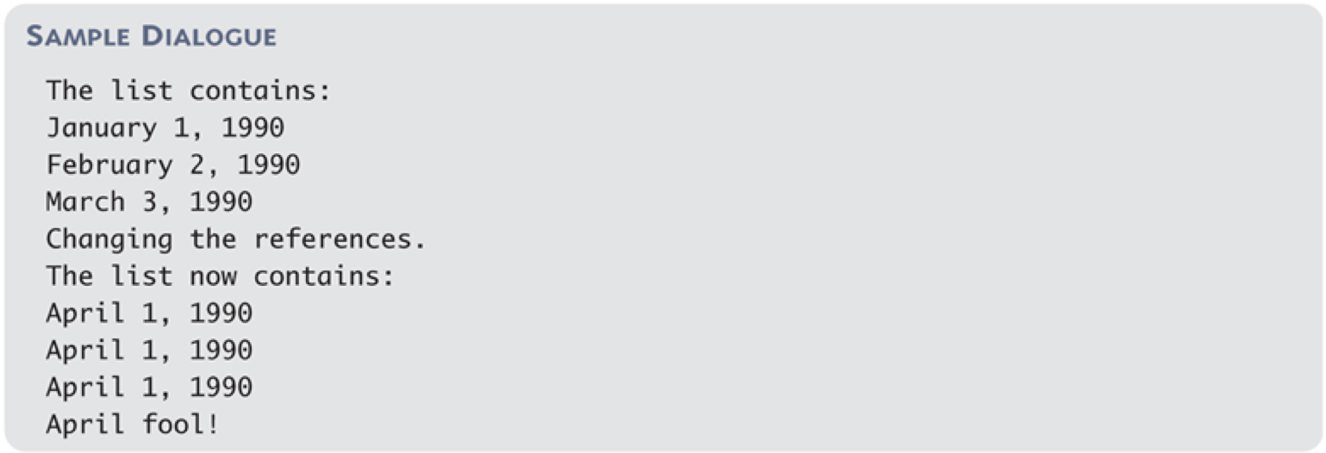

- Programmer-defined Iterator
  - suggested: derive from library collection classes
  - if collection class must be customized in some other way, then an iterator class should be defined as an inner class of the collection class

